**Genome Sequencing And Gene Editing**

Aishwarya S Muchandi

BE Student from Computer Science Department

A.P.Shah Institute of Technology,Thane

Since the illnesses, an individual experiences in a life time, are largely determined by their genetics, there has been significant interest to better understand our genetic makeup for years. Our progress was stalled by the complexity of data needed to be evaluated for understanding genetic makeup.

But now, with the advances in artificial intelligence and machine learning applications,researchers are better able to interpret and act on genomic data through genome sequencing and gene editing.

A genome sequence is a specific order of DNA building blocks (A, T, C, G) in a living organism; the human genome is made up of 20,000 genes and more than 3 billion base pairs of these genetic letters. Sequencing the genome is a critical first step to understanding it.

The latest technology called **high-throughput sequencing (HTS)** allows the sequencing of DNA to occur in one day—a process that once took a decade when it was first done. When changes are made to DNA at a cellular level, it’s called gene editing.

Gene technology is restricted to a particular gene, hence it will differ from person to person. Hence it promises the development of precision or personalized medicine. Machine Learning will help identify patterns within genetic data sets and then computer models can make predictions about an individual’s odds of developing a disease or responding to interventions.

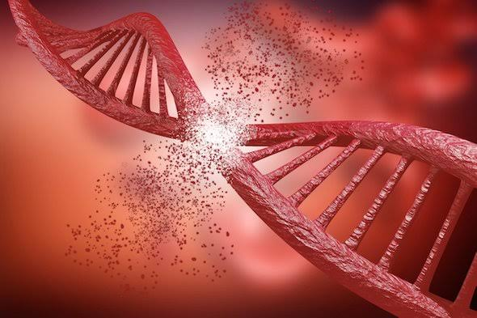

**Google’s tool DeepVariant** uses the latest AI techniques to turn high-throughput sequencing (HTS) into a more accurate picture of a full genome. While HTS was available since the 2000s, DeepVariant is able to distinguish small mutations from random errors. Deep learning was instrumental in effectively training DeepVariant.

The Canadian start-up **Deep Genomics** uses its AI platform to decode the meaning of the genome to determine the best drug therapies for an individual based on the DNA of the cell. The company’s learning software analyzes mutations and uses what it’s seen in the hundreds of thousands of mutation examples it’s analyzed to predict the impact of a mutation.

**CRISPR** ,a gene-editing technology, is a collaboration between computer scientists and biologists. There are positive outcomes for “editing out” genes that might cause disease or “editing in” genes that create high-yielding, drop-resistant crops, but it also introduces complex ethical, moral and legal implications. Most people can see the benefits of “optimizing” health by editing mutated genes, but the issue is more complex when we begin to “optimize” the human race.

Another thing experts are working to resolve in the process of gene editing is how to prevent off-target effects—when the tools mistakenly work on the wrong gene because it looks similar to the target gene.

One way of Approach is to design the learning systems extract heuristics from existing adaptive systems. Genetic Algorithms are Heuristic learning models based on principles drawn from natural evolution and selective breeding. Genetic Algos are also applied in areas of traditional ML problems,including concept learning from examples,learning weights for neural nets and learning rules for sequential decision problems.

The chromosome of the genetic algorithm represents a set of condition action rules for controlling any functions or actions of robot.The performance is measured on a resulting control strategy (using stimulator) in advesrse conditions such as; tracking a prey,seeking a goal while avoiding obstacles,Thus learning from multi-agent environments and also from the behaviour exhibited from external agents. So hence focussing on learning competitive strategies against an opponent which is itself a leraning agent.

This is a usual situation in natural environments in which multiple species compete for survival.

So initial studies lead us to expect that genetic learning systems can successfully adapt to changing environmental conditions

Artificial intelligence and machine learning help make gene editing initiatives more accurate, cheaper and easier.The future for AI and gene technology is expected to include genetic screening tools for newborns, enhancements to agriculture and more.

While we can't predict the future, one thing is for sure: AI and machine learning will accelerate our understanding of our own genetic makeup and those of other living organisms.